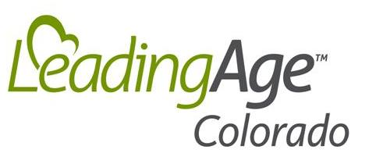
303 E. 17th Ave., Suite 880
Denver, CO 80203
P: (303) 837-8834
F: (303) 837-8836
info@LeadingAgeColorado.org

LeadingAge Colorado 2023 Business Membership Investment Invoice

Business Name: ____

Address: ____

City, State, Zip: ____

Phone: Fax: ____

Contact Person: Title: ____

Email: ____

Voting Member (if different from Contact Person): __________________________________________________________

Products or Services: ____

Website Address: ____

Home Office (if different): ____

Home Office Address: ____

Home Office City, State, Zip: ____

Dues Options (Choose only one from list):

$1,200 Standard Business Membership

$600 Small Business Membership (company has five or less employees)

$600 Affiliate member (non-voting, affiliate membership – available only to educational institutions, government agencies & professional associations)

TOTAL DUES REMITTANCE: $

Return this original invoice to LeadingAge Colorado with your payment.
Mail to: LeadingAge Colorado
303 E. 17th Avenue Suite 880
Denver, CO 80203

Or Register Online at: https://www.leadingagecolorado.org/business-membership

LeadingAge Colorado (LAC) dues are not deductible as a charitable contribution for federal income tax purposes but may be partially deducted as a business expense. LAC estimates that 9% of your state membership dues are allocable to lobbying activities of LAC, and therefore are not deductible for income tax purposes.

