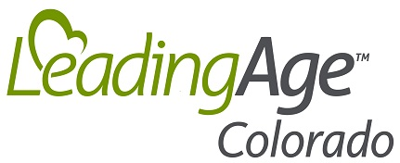

LeadingAge Colorado Assisted Living Conference
Thursday, September 25, 2025
Covenant Living of Colorado
9153 Yarrow St, Westminster, CO 80021

8:00 AM – Registration, continental breakfast, tour of exhibits

9:00 – 10:00 AM
SURVIVING SURVEYS: ENSURE YOU ARE PREPARED OPERATIONALLY AND LEGALLY
Maintaining regulatory compliance is a critical yet complex challenge for assisted living organizations. This session equips attendees with proven strategies to proactively manage the survey process. Explore best practices for documentation, policy management and staff training to ensure survey readiness. Gain insights on effectively contesting deficiencies and addressing repeat citations to safeguard your organization's licensure. Leverage expert guidance to foster a culture of regulatory compliance and mitigate operational and legal risks.

Peggy Kozal, Dickinson Wright, PLLC; Ericka Devos, Legend Senior Living

10:00 – 10:45 AM
Hot Topics in Fire & Life Safety: Trends, Troubles & Solutions
Stay up to date with the latest developments in fire and life safety from the Colorado Division of Fire Prevention & Control. Bryan Adams, Inspection Unit Chief, will discuss current trends, frequently cited deficiencies from recent inspections, and anticipated changes to regulations and policies. He will also address jurisdictional challenges—particularly the interactions between state and local authorities—and provide practical guidance on how assisted living residences can navigate differing regulatory interpretations.
The session will conclude with a Q&A segment, offering attendees the chance to raise specific concerns and receive expert advice on staying compliant with evolving safety standards.
Bryan Adams, Inspection Unit Chief, Colorado Division of Fire Prevention & Control; Pete Anderson, Acute Health Care Unit Chief for the Department of Fire and Public Safety (DFPC)
10:45 - 11:15 AM – Break and tour of exhibits
11:15 AM – 12:15 PM
SMART CARE IN THE CENTENNIAL STATE: HOW COLORADO ASSISTED LIVING PROVIDERS ARE USING AI
Colorado assisted living providers are integrating AI into daily operations while keeping resident care at the center. This panel will highlight real-world examples of AI in action, including fall detection systems, personalized resident activity planning, administrative support tools, and marketing applications. Panelists will discuss both the opportunities and challenges of adopting these technologies, including privacy considerations and the balance between AI efficiencies and human interaction.
Moderator: Robin Visser, Christian Living Communities
Panelists: Kaleigh Perez, The Argyle; Christopher Pogar, Hemsley House at University Park; Kristal Wynn, The Ridge Pinehurst
12:15 -1:15 PM – Networking lunch and tour of exhibits
1:15 – 2:30 PM
ASSISTED LIVING SURVEY AND REGULATORY UPDATE
Join Dr. Steve Cox, DNP, RN, Branch Chief at the Colorado Department of Public Health & Environment (CDPHE), for a comprehensive update on assisted living surveys and regulatory changes. This session will cover the current survey process, top deficiencies cited, enforcement actions and common Immediate Jeopardy citations—along with practical guidance to help providers maintain compliance. Additionally, topics covered will include recent legislative updates impacting ALRs and changes to Chapter 2 regulations.
Dr. Steve Cox, DNP, RN, Branch Chief, Health Facilities & Emergency Medical Services Division (HFEMSD), CDPHE
2:30 - 2:45 PM - Break and tour of exhibits
2:45 – 3:30 PM
Medication Oversight in Assisted Living: Practical Strategies to Prevent Citations
Medication management remains one of the most frequently cited areas of noncompliance in assisted living communities. In this session, Sara Wright of Assisted Living Consultants of Denver will highlight the most common medication-related deficiencies identified during surveys and provide actionable strategies to address them. Attendees will gain practical tools to improve compliance, enhance documentation, and strengthen internal audit processes—ultimately supporting survey readiness and elevating quality of care.
Sara Wright, Assisted Living Consultants of Denver

2025 Assisted Living Conference Sponsors and Exhibitors

Presenting Sponsor



Lunch Sponsor



Exhibitors
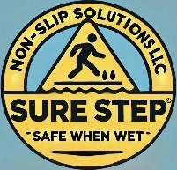
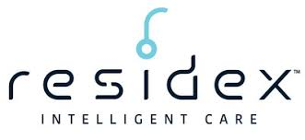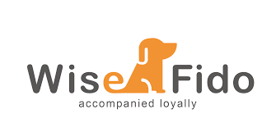

Sponsors
