
Overview
This session will provide caregivers with in-depth information about possible factors that affect intake for individuals with dementia. It will also help them identify concerns and intervene to promote safe and effective eating behaviors and programs throughout the progression of the disease. The program will cover a variety of strategies and techniques to help caregivers effectively notice and address concerns and progress, provide the ‘just right’ amount and type of assistance, create environments and set-ups that help with meals, and maximizes the dining experience for people with dementia throughout their life. This webinar is appropriate for skilled nursing, assisted living and home and community-based providers.

Learning Objectives
By the completion of the presentation, attendees will:
- Discuss aspects of dementia that affect nutrition and oral intake.
- Match common issues at each level of dementia to interventions that address nutritional or oral intake concerns at that point.
- Determine whether nutrition and eating support is being optimized at each level based on the person’s abilities, needs, and disease status.

Who Should Attend
Administrators, Memory Care staff, Dietary Staff, Nursing Staff, Staff Educators, Activities and Social Workers. Skilled nursing, assisted living and home and community based providers.

Faculty
Teepa Snow, MS, OTR/L, FAOTA, President, Positive Approach, LLC, Efland, NC
Today’s Voice for Dementia, Teepa Snow is one of the world’s leading advocates and educators for anyone living with dementia.

Teepa Snow is an occupational therapist with 40 years of rich and varied clinical and academic experience.
She graduated from Duke University and has an MS degree from the University of North Carolina in Chapel Hill. Teepa has more than 35 years of clinical experience in the field of geriatrics and dementia care, as well as having provided care to family members with dementing illnesses. She presents with extraordinary expertise and humor to audiences large and small throughout the world. Her company, Positive Approach® to Care (PAC) provides on-line and in-person services, training, and products to professionals, family members, the lay public, and people living with brain changes internationally. Her GEMS® State Model for understanding progression and change in ability, combined with her PAC™ Skills, form practical and effective strategies and techniques for individuals and agencies seeking to optimize care and support for those living with dementia and their care partners.

Teepa Snow Presents:
Eating & Nutritional Issues
in Dementia Care
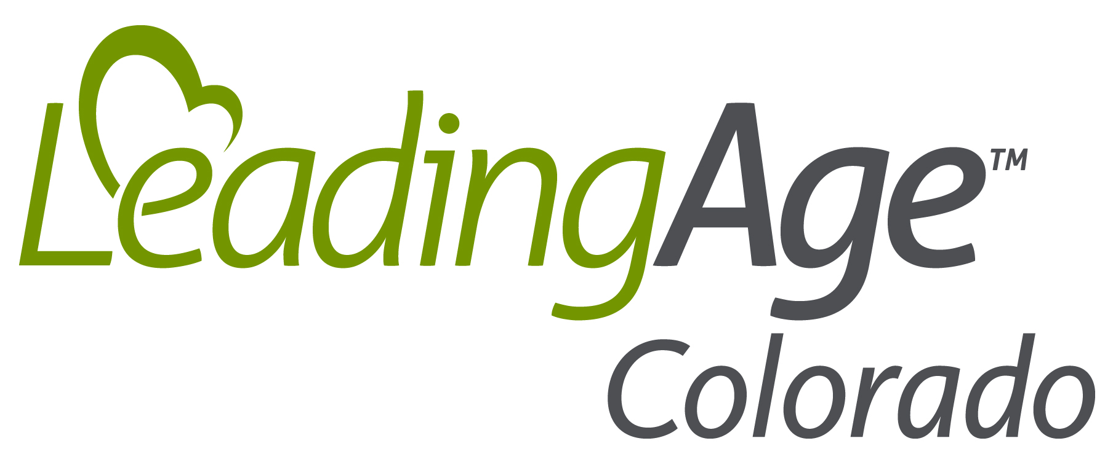

Tuesday, March 17, 2020
1:15 p.m. – 2:15 p.m. MST

Registration Deadline:
Monday, March 16, 2020

Questions?
Contact LAC at 303-837-8834 or email us at sarah@leadingagecolorado.org

Refund Policy
No-shows will be billed. No refunds for
failure to log-in at the time of the event.
Substitutions welcome anytime via fax or
email. All cancellation and substitution requests must be emailed to Sarah McVeigh
(sarah@leadingagecolorado.org).
A full refund will be given to all cancellations received 10 or more business days prior to
the program. A $25 administrative fee will be charged to all cancellations received six to
nine business days prior to the program.
No refunds will be given to cancellations received five or fewer business days prior
to the program. Refunds will be calculated
by the date received and the LeadingAge Colorado business days remaining prior to the program. LeadingAge Colorado reserves the right to cancel the program due to insufficient enrollment in which case pre-registered participants will be notified and full refunds provided.

Register at
www.LeadingAgeColorado.org

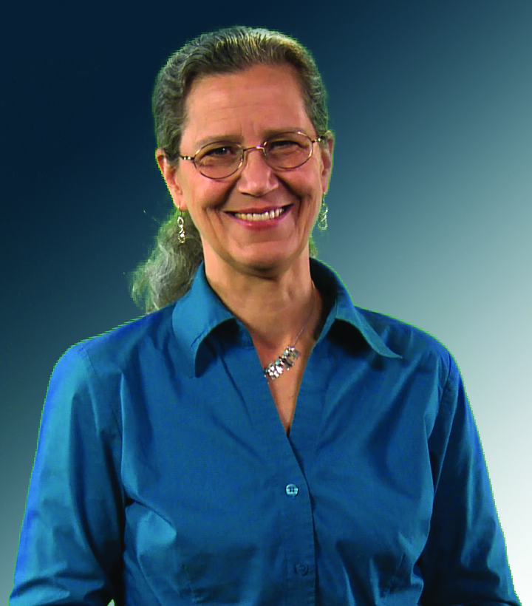

Teepa Snow Presents:
Eating & Nutritional Issues
in Dementia Care

Registration Information & Fees
Register at www.LeadingAgeColorado.org. Fees are per connection at a facility. Registration instructions and handout materials will be sent to the contact person listed on the registration 1 day prior to the program.

LeadingAge Colorado Member $70
Prospective Member $105

Registration fee includes electronic handout and one connection to the live webinar. A recording of this webinar is NOT included in the registration fee.

